Transcriptome annotation and profiling of oleaginous *D. armatus* under biotic and abiotic stress conditions

*D. armatus* strain SE107 was grown year around in open pond system. The biomass was harvested and used to extract crude oil. The growth rate and biomass productivity of the strain varied due to environmental conditions. In this study, we have determined the changes in the transcriptome of *D. armatus* in response to extreme temperatures and pests. The genome of the strain was sequenced and an annotation was obtained.

Abiotic stress:

The strain SE107 was inoculated to the plate reactors at 0.2 g/L in 6AC3109 media. They were grown in the plate reactors until the biomass reached to 0.3g/L under the growth conditions (temperature and light intensity) that simulated July conditions at New Mexico site where the production ponds are operated. See figure 1A and 1B.

Once the culture reached 0.3g/L, the temperature of one set of plate reactors (8 plate reactors) were increased and kept at 37°C and another set of 8 was decreased to 10°C. A set of 8 plate reactors were left as they are and used as controls. In all plate reactors diurnal light cycling continued. Time course samples were collected at 0, 1, 3, 6, 9, 12, 24, 48 and 72 hours for RNA isolation.

Biotic Stress:

The strain SE107 was inoculated to 800 mL 6AC3109 media and were grown in flasks. The flasks were placed into growth boxes with 2% CO2 and diurnal cycling of 14 hours light and 10 hours dark, temperature between 20-30 °C. Once the culture reached 0.3g/L, a set of 3 flasks were inoculated with chytrid FD, another set of 3 with rotifers. A set was kept as the control. Time course samples were collected at 0, 1, 3, 6, 9, 12, 24, 48 and 72 hours for RNA isolation.

RNA sequencing:

The time points 0, 1, 3, 9, 24 and 72 hours were selected for sequencing. The samples were sequenced for each time point. The abiotic stress treatment had 8 biological replicates. Before sequencing they were pooled in to two groups each pool contained samples from 4 plate reactors. The biotic stress had 3 biological replicates and two of those were sequenced.

RNA samples were sequenced with Illumina HiSeq 15 million reads/ sample and 1x50pb single end reads.

Figure 1: Light (A) and temperature (B) conditions in the plate reactors were based on the July New Mexico cycle obtained by LCTS weather station

1. Light

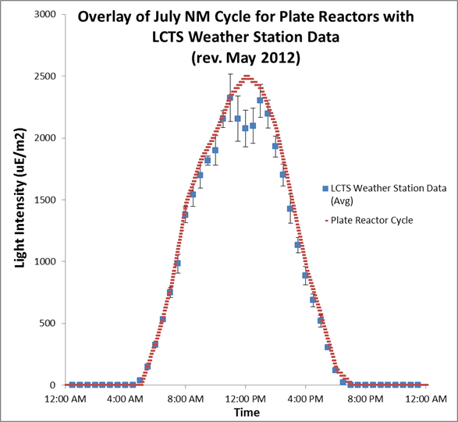

1. Temperature

